**3. Views and Built-in Functions**

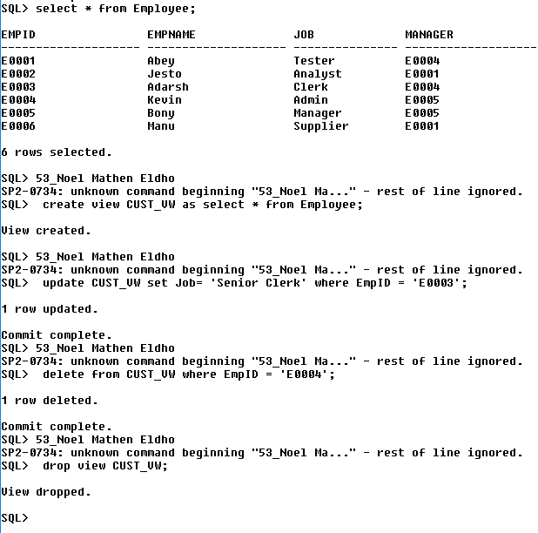

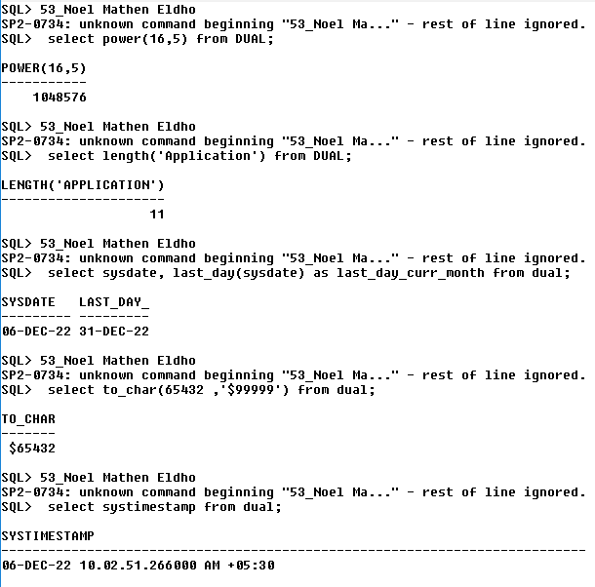

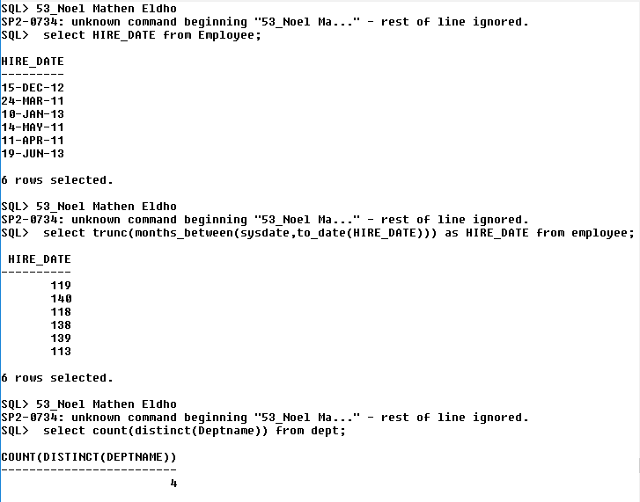

Commit complete.

SQL> select * from Employee;

EMPID EMPNAME JOB MANAGER

-------------------- -------------------- --------------- --------------------

E0001 Abey Tester E0004

E0002 Jesto Analyst E0001

E0003 Adarsh Clerk E0004

E0004 Kevin Admin E0005

E0005 Bony Manager E0005

E0006 Manu Supplier E0001

6 rows selected.

SQL> 53_Noel Mathen Eldho

SP2-0734: unknown command beginning "53_Noel Ma..." - rest of line ignored.

SQL> create view CUST_VW as select * from Employee;

View created.

SQL> 53_Noel Mathen Eldho

SP2-0734: unknown command beginning "53_Noel Ma..." - rest of line ignored.

SQL> update CUST_VW set Job= 'Senior Clerk' where EmpID = 'E0003';

1 row updated.

Commit complete.

SQL> 53_Noel Mathen Eldho

SP2-0734: unknown command beginning "53_Noel Ma..." - rest of line ignored.

SQL> delete from CUST_VW where EmpID = 'E0004';

1 row deleted.

Commit complete.

SQL> 53_Noel Mathen Eldho

SP2-0734: unknown command beginning "53_Noel Ma..." - rest of line ignored.

SQL> drop view CUST_VW;

View dropped.

SQL> 53_Noel Mathen Eldho

SP2-0734: unknown command beginning "53_Noel Ma..." - rest of line ignored.

SQL> select power(16,5) from DUAL;

POWER(16,5)

-----------

1048576

SQL> 53_Noel Mathen Eldho

SP2-0734: unknown command beginning "53_Noel Ma..." - rest of line ignored.

SQL> select length('Application') from DUAL;

LENGTH('APPLICATION')

---------------------

11

SQL> 53_Noel Mathen Eldho

SP2-0734: unknown command beginning "53_Noel Ma..." - rest of line ignored.

SQL> select sysdate, last_day(sysdate) as last_day_curr_month from dual;

SYSDATE LAST_DAY_

--------- ---------

06-DEC-22 31-DEC-22

SQL> 53_Noel Mathen Eldho

SP2-0734: unknown command beginning "53_Noel Ma..." - rest of line ignored.

SQL> select to_char(65432 ,'$99999') from dual;

TO_CHAR

-------

$65432

SQL> 53_Noel Mathen Eldho

SP2-0734: unknown command beginning "53_Noel Ma..." - rest of line ignored.

SQL> select systimestamp from dual;

SYSTIMESTAMP

---------------------------------------------------------------------------

06-DEC-22 10.02.51.266000 AM +05:30

SQL> 53_Noel Mathen Eldho

SP2-0734: unknown command beginning "53_Noel Ma..." - rest of line ignored.

SQL> select HIRE_DATE from Employee;

HIRE_DATE

---------

15-DEC-12

24-MAR-11

10-JAN-13

14-MAY-11

11-APR-11

19-JUN-13

6 rows selected.

SQL> 53_Noel Mathen Eldho

SP2-0734: unknown command beginning "53_Noel Ma..." - rest of line ignored.

SQL> select trunc(months_between(sysdate,to_date(HIRE_DATE))) as HIRE_DATE from employee;

HIRE_DATE

----------

119

140

118

138

139

113

6 rows selected.

SQL> 53_Noel Mathen Eldho

SP2-0734: unknown command beginning "53_Noel Ma..." - rest of line ignored.

SQL> select count(distinct(Deptname)) from dept;

COUNT(DISTINCT(DEPTNAME))

-------------------------

4

SQL> 53_Noel Mathen Eldho

SP2-0734: unknown command beginning "53_Noel Ma..." - rest of line ignored.

SQL> select to_char(HIRE_DATE, 'DY,DDth MONTH,YYYY') from Employee;

TO_CHAR(HIRE_DATE,'DY,D

-----------------------

SAT,15TH DECEMBER ,2012

THU,24TH MARCH ,2011

THU,10TH JANUARY ,2013

SAT,14TH MAY ,2011

MON,11TH APRIL ,2011

WED,19TH JUNE ,2013

6 rows selected.

SQL>